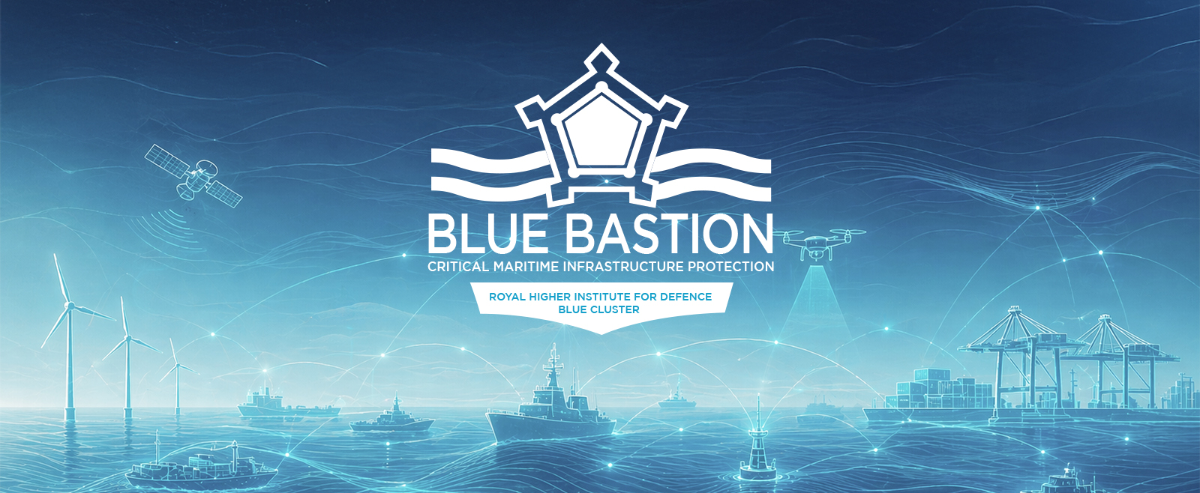
BLUE BASTION DEMONSTRATOR
Call for proposals 2026

DATA MANAGEMENT PLAN
Compulsory document - must be completed - in English
Before completing, please consult carefully the Information Document on https://www.blauwecluster.be/blue-bastion-innovatieprojecten
! Only fully completed templates will be considered for evaluation!
Please note that the font used to complete the documents must be in Calibri, size 11, with 1,15 line spacing.

Please note that the font used to complete the documents must be in Calibri, size 11, with 1,15 line spacing.

PROPOSAL'S ID
Project Acronym | Click here to enter text.
Project Title | Click here to enter text.

Will data be collected, reused and/or generated?

Please select the adequate answer(s) taking into account the following concepts:

- Data content:
Refers to the type of data regarding what it contains. E.g. numeric (databases, spread sheets), textual (documents), image, audio, video, mixed media…
- Data format:
Refers to the technical format of data; to the way in which the data is encoded for storage, often reflected by the filename extension. For example: pdf, xls, doc, txt, rdf…
- Data volume:
You may roughly estimate this using the following categories: From 0 – 10GB; From 10 – 100 GB; From 100 – 1000 GB; More than 1000 GB.

My proposal will… | ☐ COLLECT DATA  ☐ REUSE EXISTING DATA  ☐ GENERATE NEW DATA
Please describe:
- Which data you will collect/reuse/generate
- How data will be collected / from which source it will be reused / how will it be generated
- Its content, technical format and estimated volume.
- Any existing constraints regarding its use.

How will you handle legal issues?

Please answer the following statements taking into account the following concepts:

Legal issues: This includes personal data, intellectual property issues and security requirements. Regarding personal data, you must ensure when dealing with personal data that Data Protection Laws (i.e. GDPR) are complied with.

My proposal will use / process / store personal data: | ☐ YES  ☐ NO
If your answer is ‘YES’: shortly describe the kind of personal data.
Add the process and reference to your file in the partners' privacy register.
The work undertaken in the project will possibly result in research data with potential for technology transfer and valorisation: | ☐ YES  ☐ NO
If your answer is ‘YES’, your proposal must take into account possible intellectual property issues.
Explain who will be the owner of the data (who will have the rights to control access).
Indicate whether there will be intellectual property rights/restrictions for the data you created, and if applicable, describe how these will be managed.
The work undertaken in the project will possibly use or generate classified information. | ☐ YES  ☐ NO
If your answer is ‘YES’, your proposal must take into account possible security requirements (see section 7.3. of the information document. Identify the classification needs for the work packages of the project that involve threat and /or vulnerability assessments and the information on specifications or capabilities of the tool(s) used.
Attention! Classified information is sensitive, but other, more stringent, rules will apply than the ones described for sensitive information in the following data management paragraphs.

How will you document your data?

Please answer the questions/statements, taking into account the following information:

Data must comply, as much as possible with FAIR principles; it must be findable, accessible, interoperable and reusable. For this purpose, data must be accompanied by descriptive information in the form of metadata. Metadata is the information that describes, explains, locates, and /or makes the use of an information source easier to retrieve. Where metadata are in place, researchers are advised to use and mention metadata standards.

What documentation will be provided to enable understanding and reuse of the data collected / generated in this project?
Metadata standards will be used: | ☐ FOR ALL DATA  ☐ FOR SOME DATA  ☐ FOR NONE OF THE DATA
- if your answer is ‘for all data’ or ‘for some data’, please describe in detail which standards will be used.
- if your answer is ‘none of the data’, please state in detail which metadata will be created to make the data easy/easier to find and reuse.

Data storage and backup during the project

Please give preference to the use of robust, managed storage with automatic backup, such as networked drives, which offer ample storage space and data security for most purposes.
Consider data protection, particularly if your data is sensitive – for example, containing personal data, politically sensitive information or information relating to religion and health. If this is your case, enquire with the partners' support staff whether your intended storage solution meets the data security policy.

Please answer the statements/questions, taking into account the following information. Note that you may choose one or more answers.

The data will be stored in… | ☐ the partner's Research Storage  ☐ OTHER
If your answer includes ‘OTHER’:
- Specify which storage solutions you will use during the project, in addition to / instead of the partner's research storage.
- Explain the reasons for using these solutions. E.g. because you need more space than available by the partners; to facilitate data sharing with collaborators; or because your data requires additional security.
How will the data be backed up?
How will data security and protection of sensitive data be taken care of during the research? |  | ☐ Not applicable (there are no sensitive data)  ☐ Default security of the partners' networked research storage  ☐ Additional security measures
If your answer is other than ‘Not applicable’: Describe the main risks and how these will be managed.
What are the expected costs for data storage and backup during the project? How will these costs be covered?
Costs related to data storage and backup during the project can be covered by the project budget providing these are fully justified and relate to the project.

Data preservation in the long term - after the project

Please answer the following questions/statements, taking into account the following information. Note that you may choose one or more answers to the second statement.

The data generated during the project should be preserved (archived) in the long term, in as far as legal and contractual agreements allow. As rule of thumb, long-term storage is considered to be at least 10 years, unless legal provisions or discipline-specific guidelines dictate otherwise.

All data will be preserved in the long term (at least 10 years) |  | ☐ YES  ☐ NO
If your answer is ‘NO’: clearly describe what data will be preserved long-term and what data will be destroyed for contractual, legal or regulatory purposes, or for physical preservation issues. Indicate how you will decide which data to keep.
The data will be archived within… | ☐ Partners' Networked Research Storage  ☐ OTHER
If your answer includes ‘OTHER’: Specify which storage solutions you will use in the long term, in addition to/instead of the partners' networked research storage. Please explain the reasons for using these solutions.
How will data security and protection of sensitive data be taken care in the long term? | ☐ Not applicable (there are no sensitive data)  ☐ Default security of the partners' networked research storage  ☐ Additional security measures
If your answer is other than ‘Not applicable’: Describe the main risks and how these will be managed. Inquire with your partners' support staff whether your intended storage solution meets the data security policy if your research involves sensitive data.
What are the expected costs for data preservation in the long term? How will these costs be covered?
Costs related to data preservation in the long term can be covered by the project budget providing these are fully justified and relate to the project.

Data sharing and reuse

Please answer the following questions taking into account the following information:

As stated before, data must comply, as much as possible with FAIR principles; it must be findable, accessible, interoperable and reusable. It is thus important that you provide information regarding data sharing and reuse.
If applicable, data sets will be linked to the scientific publications they underpin and which have either been deposited in.
Note that the data available for sharing and reuse may differ from the preserved data, since there may be legal, IP, privacy or security related reasons preventing or restricting the access to data, or lacking of space for large data volumes to deposit them in a repository in its entirety. This could be the case for part or the entirety of data; in the short, mid or long term. A staged approach will provide access for communities of certified users, adapting the degree of certification of users to the sensitivity of the data.

Are there any factors restricting or preventing the sharing or reuse of the data  (e.g. agreements with 3rd parties): |  | ☐ YES  ☐ NO
If your answer is ‘YES’: explain which data are affected by this agreement.
State the restrictions that are in place.
Which data will be made available to the public? |  | ☐ ALL  ☐ SOME PART  ☐ NONE
If your answer is ‘SOME PART’ or ‘NONE’:
- Indicate the restrictions on the sharing of the data (why can’t it be shared)
- Explain what data sharing agreement will be implemented
Where/how will data be made available to the public? | ☐ In a restricted access repository  ☐ Upon request by mail  ☐ Other (specify)
When will data be made available to the public? | ☐ As soon as corresponding communication(s) are published  ☐ After the project is finished  ☐ After the completion of the project (with embargo)
If your answer is other than ‘as soon as corresponding communication(s) are published’: Indicate the reasons for the restrictions on the time release of data (embargo periods). For example, to publish, protect intellectual properties, or seek patents.
Who will be able to access the data and under which conditions?
Which data will be made available for re-use? | ☐ ALL  ☐ SOME PART  ☐ NONE
If your answer is ‘SOME PART’ or ‘NONE’: Indicate the restrictions on the re-use of the data. Explain what actions could be taken to overcome or to minimize restrictions.

Responsibilities

Please answer the following questions/statements, taking into account the following information:

Who will be responsible for the data documentation & metadata?
In case of the use of personal data, please note the name and contact data of the concerned data protection officers.
Who will be responsible for data storage & back up during the project?
Who will be responsible for ensuring data preservation and sharing?
Who bears the end responsibility for updating & implementing this DMP?
Default response: The project coordinator bears the overall responsibility for updating & implementing this DMP.

